Traffic monitor
The project consists in a system capable of managing the traffic and give virtual informations to the drivers. The drivers are able to send information to the system (e.g. An accident in traffic could be reported sending the street where it happened, the hour, and a text message with other mentions and the system sends it to every client logged in at that moment; Automatically every client (car) will send its speed to the system, and the system sends back information about speed limits;). Every driver can subscribe to a weather service, sport events or fuel price information service. Every one of this services send the specific information to the client daily.

The server will be a TCP server with concurrency. This will allow multiple clients to be connected to the server at the same time. The concurrency will be assured by multiple threads. So, for each new client connected to the server, it will create a new thread for that specific client. This will be done with the help of "pthread" library. Also, to avoid synchronization problems caused by shared resources(e.g. an array of socket descriptors; a variable that stores the number of connected clients; ...) between threads there will be used mutexes. This way, the portions of code, that can cause any synchronization issue, will be locked when used by a thread.
The server will be separated in multiple services, on different threads. For example there will be a thread responsible for broadcasting, that means any message that needs to be sent to all clients will be redirected to the broadcasting service (thread) and then sent to the clients. Another service will listen for any Event (e.g. accident, traffic jam ...) received from any user and take action (redirect it to the broadcast service). The weather, sports and price information services will send the specific information only to the client that subscribed for that service. Another service to receive information about speed and location, in order to respond with the speed limit for that area. As an example of a possible synchronization issue we can assume that the Broadcasting service and the Weather service need access to the socket descriptor array in order to send the data. Using mutexes, the safety of both threads can be ensured, the Broadcast service will send data to all clients and the Weather service will send data only for those who subscribed to this service.
The client will also have two different threads, one main thread, and a thread for receiveing messages sent by the Broadcast service. In order to be able to recieve any message sent through the Broadcast service, the thread responsible for receiveing messages will stay connected permanently. And the main thread will perform a connect when it sends a request. To keep track of clients I will use a data structure as follows:
struct credentials{
char clientId[11];
byte subscribtions[3];
}
The first time a client connects to the server it will assign a socket descriptor and starts the thread for that client. It will assign a client id to that client, and will save it in a file. And then it sends back to the client its "clientId". The client will update the "credentials" structure and will save it to a local file. And every time it connects it will send the "clientId" as a prefix of its request. This way the server knows where the data comes from, and it will use the socket descriptor assigned to that "clientId" until it disconnects.
Server client credentials:
struct clientCredentials{
char clientId[11];
int sd;
byte subscribtions[3];
}
The client performs the disconnect action by sending a disconnect request and the server will "softly" cut the connection: closes the active file descriptor and it clears the "sd" field in "clientCredentials".
The user can update the subscribtions by updating them in the client, and then, same as the "clientId", the client sends the "subscribtions" field to the server, which will update it too. Every time the client will connect to the server, it will receive the information it is subscribed to.
Below is the diagram that shows the communication between client and server, and communication between services for each one.
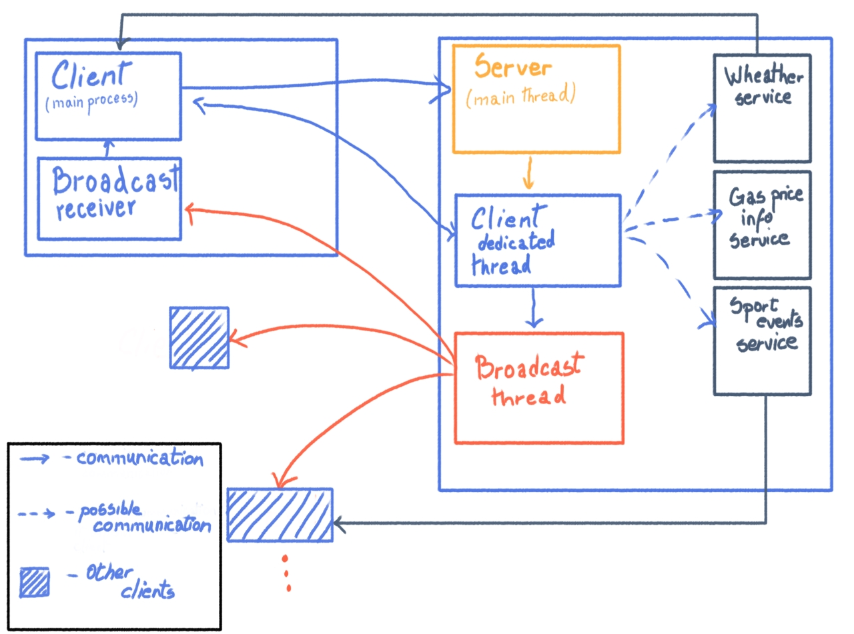
To a better understanding of the diagram: the communication between Client (main process) and Server (main thread) consists in connection. The communication between Client (main process) and Client dedicated thread is the communication itself, that can be done both ways, consisting in sending and receiving messages. The communication between Broadcast receiver in client and Client (main process) is a one way communication, Broadcast receiver is letting Client (main process) know what message has been received from the Broadcast on the server. The Client dedicated thread communicates with the Broadcast thread, this consists in passing a message to be sent further to all Clients. It communicates with the Weather service, Sport events service and Gas price information service only if the user is subscribed to it. In the diagram it is clear that the first client is subscribed to Weather service, and so, the Weather service communicates directly with the Client (main service), and the third client is subscribed to the Sport events service, and yet again the Sport events service communicates directly with it. This communication consists on sending a message from the service to the client.
To take a quick look at how the server work, I provide the following instructions:

struct sockaddr_in thisAddress;
struct sockaddr_in clientAddress;
int sd, sd2;
int port;
int addrLength;
pthread_t threadId;

memset((char *)&thisAddress,0, sizeof(thisAddress)); /*memory allocation for the data structure that holds the server address*/
thisAddress.sin_family = AF_INET;
thisAddress.sin_addr.s_addr = htonl(INADDR_ANY); /*IP address of the server is the local IP adress: 127.0.0.1*/

port = PORT;
thisAddress.sin_port = htons(port);

this is the initialization of the structure needed to get the server up and running. Along with some global variables:
pthread_mutex_t mut = PTHREAD_MUTEX_INITIALIZER; /*mutex variable*/

#define PORT 8888 /*connection port*/
#define MAXCLIENTS 2 /*maximum number of clients that could connect*/

int noOfClients = 0; /*number of clients currently connected*/
int sdArray[MAXCLIENTS]; /*array of clients*/

The MAXCLIENTS can be increased as much as the hardware allows, or even ignored entirely. noOfClients comes in help especially when sending a broadcast message, to know exactly how many clients are active.
In the following lines we can see creation of a socket descriptor, binding with the ip address and start listening:
sd = socket(PF_INET,SOCK_STREAM,0);
if(sd<0){
perror("Something went wrong at socket creation\n");
exit(1);
}

if(bind(sd,(struct sockaddr *)&thisAddress, sizeof(thisAddress)) < 0){
perror("Something went wrong at bind\n");
exit(1);
}

if(listen(sd, MAXCLIENTS) < 0) {
perror("Something went wrong at listen\n");
}
addrLength = sizeof(clientAddress);

Next lines are the main thread of the servers which accepts requests and creates a Client dedicated thread:
while(1) {
printf("[Initial thread]: Waiting for connection\n");

if( (sd2 = accept(sd, (struct sockaddr *)&clientAddress, &addrLength)) < 0 ) {
perror("Something went wrong at accept\n");
exit(1);
} else printf("[Initial thread]: Client accepted with SOCKET DESCRIPTOR %d\n",sd2);

pthread_create(&threadId, NULL, &clientDedicatedThread, (void *) &sd2);

}
close(sd);
}

The function needed to be sent as a parameter on pthread_create() that contains the logic is:

void * clientDedicatedThread( void * param){

int clientSd;
clientSd = *(int*)param;
pthread_mutex_lock(&mut);
sdArray[noOfClients-1] = clientSd;
pthread_mutex_unlock(&mut);

[…]
pthread_exit(0);
}

In this function takes place all the communication. Here it will be found a requestHandler() that take as parameters the message received from the client, evaluates the request and then triggers a specific action. This action consists in a separate function that will be called.

Other mentions: the data on the server will be saved in a data base simulated by files. (e.g. Name of streets; User credentials; Speed limitations with respect to certain streets/zones; Moths with temperature ranges;…). Speed value for example, that is needed under certain conditions (to be sent from client to server) will be generated randomly. The subscription based services will store data in the same way, simulating a data base with files and generating randomly information about sport events or gas price or temperature with respect to the ranges stored in the so called “data base”. The client will simulate a GPS storing all locations in a file and get a random one.

As some improvements I would change the clientId, to a be a auto-generated in in the client as a car serial number, this way every client will have a unique clientId and the server is not supposed to assign it and then send it back, it will just receive it and save it. Or to take it further, a registration/login process in both client and server. In client to build the data structure created in the registration and then send it to the server where it will be saved, of course linking the car serial number to the account, with the possibility of linking one or more cars to one account. In the login the client will send just the user name and password, and receive access, after the server search and find the user in a data base simulated by a file. Please note that the project itself is incomplete and under a rough (basic) form, everything could be subject to change.
As a bibliography I used the courses and laboratories for both materials and examples. For more examples and further information I used man7.org/linux/man-pages/ and linux.die.net/man/.

